Mammalian Brain Increases are Unrelated to Global Climate

Brian M. Schilder¹, W. Andrew Barr¹, René Bobe¹, Chet C. Sherwood¹

¹Department of Anthropology, Center for Advanced Study of Human Paleobiology,
The George Washington University, USA

E-mail address: schilder@gwu.edu
Mailing address: Science and Engineering Hall, 800 22nd St NW, Washington, DC 20052, USA
Telephone: 1-202-994-5923 (Lab)

Keywords: Variability selection, brain evolution, paleoclimate, isotopes, temporal autocorrelation

- Abstract
  - Orders
  - Climate multiple regressions
  - Temporal autocorrelation
- Introduction
  - Orders previously investigated for CC vs. climate
  - Competing hypotheses
    - Trend selection
    - Variability selection
    - Rate selection (novel)
  - Temporal autocorrelation
- Materials
  - Climate data (intervals)
  - Fossil data
  - Ancestral state reconstructions
- Methods
  - CC vs. Time linear regressions
  - Multiple regressions
  - Detrending time series data
- Results
  - Fossils: CC vs. Time (Fossils, Ancestrals)
  - High, Moderate, or Low Confidence
  - CC vs. Climate
    - Fossils: Trended vs. Detrended
    - Ancestrals: Trended vs Detrended
- Discussion
  - Limitations
    - There’s no defined interval of
  - Not all possible climatic variables were tested, but this could be used as a framework for others to investigate climate and evolutionary changes.
    - Step I: Identify which orders show significant changes over time.
    - Step II: Analyze those orders in multiple regressions models.
    - Step III: Account for temporal autocorrelation.
  - Can be extended to other biological data vs. other time series data.
  - We found that climate did predict CC in some mammalian orders, but not Hominins, contradicting other prominent hypotheses of brain evolution (e.g. turnover-pulse hypothesis, variability selection hypothesis).
    - Does not necessarily exclude possibility of shifts in carbon record, or regional or local climate shifts (not tested here) predict Hominin CC.
- Conclusions
  - Climate predicts CC of some mammals, but not Hominins.
  - Detrend yo data!

ABSTRACT

Increases in brain size over the course of evolutionary time have been observed in multiple mammalian lineages, including hominins. This has inspired a variety of competing proposals for underlying forces driving brain size increase. Large-scale changes in climate are one such proposed explanation. However different aspects of the climate (e.g. trends vs. variability) have traditionally been investigated in isolation without simultaneously considering the potential contributions of other highly interrelated climatic variables. Furthermore, previous investigations of this topic have not appropriately accounted for temporal autocorrelation by detrending time series data.
Here we investigated the relationship between different measures of the global oxygen isotope record (trend, variability, and rate of change) and cranial capacity (CC), first using a dataset of 299 fossil species representing five different mammalian orders. Analyses were then repeated using 298 ancestral CCs statistically reconstructed from extant mammals. While CC was predicted by global climate in some taxa, including primates, all analyses indicated that hominin brain size was independent of global climate. This study does not support some previous findings and describes statistical methods that should be standard in these types of investigations.

INTRODUCTION

Hypotheses of Brain Evolution

Since the divergence of hominins from other great apes 6-7 Mya, our lineage has undergone a massive expansion in brain size, such that humans have brains that are over three times larger than those of our closest extant relatives, non-human apes (Schwartz and Tattersall, 2004; Holloway, 2008; Sherwood et al., 2008; Klein, 2009; Shultz et al., 2012a). However this phenomenon is not unique to our lineage, as evolutionary increases in brain size have also been demonstrated in non-hominin primates, carnivores, artiodactlya and birds (Lefebvre et al., 2004; Shultz and Robin Dunbar, 2010).
While the precise reasons for evolving larger brains remain unclear, many hypothesis revolve around enhanced neural and thus cognitive plasticity (Lefebvre et al., 2004; Sol et al., 2005; Krubitzer, 2009; Sol, 2009). Organisms may evolve larger brain size as an adaptation to more efficiently solve novel problems and thus flexibly respond to changes in their dietary niche (Broadhurst et al., 1998; Carmody and Wrangham, 2010) or the maintenance of a complex social networks (RIM Dunbar, 1998; Shultz and R I M Dunbar, 2007; Shultz and Robin Dunbar, 2010). Large-scale changes in climate have also been proposed as the underlying driving force behind brain evolution, by indirectly influencing the evolution of organisms by altering the environment at the regional and local levels. However, which aspects of climatic change are the actual driving forces is a matter on ongoing debate. The turnover-pulse hypothesis proposes that directional trends in temperature, aridity and vegetation over time have been the primary driving force underlying hominin encephalization (Elisabeth S Vrba, 1993; 1995; Elizabeth S Vrba, 1996). In contrast, proponents of the variability selection hypothesis posit that increases in the amplitude and periodicity of global environmental fluctuations drive species to become more versatile and thus more effectively adapt to rapidly changing environments (Potts, 1996; 1998a; 1998b; 2012). One way organisms can achieve greater versatility is by adding more neurons to the brain. Increasing the number of neurons enhances compartmentalization and specialization specific brain regions for particular functions (Striedter, 2005). Ultimately this may give rise to a more complex neural network, enhanced cognitive flexibility, and a volumetric expansion of the brain. While often advertised as mutually exclusive hypotheses, this is not necessarily the case as multiple climatic factors can indirectly exert selective pressures on a population at the same time.

Previous Investigations

Previous attempts to directly test the relationship between global climate on fossil hominin brain size have concluded that climate has influenced brain size (Ash and Gallup, 2007; Bailey and Geary, 2009; Shultz and Maslin, 2013). However, the conclusions that can be drawn from these studies are limited by some notable confounds. First, none of these studies have included a sample of other mammalian taxa to see if climate has selected for larger brains as a general principle of mammalian evolution that is not unique to hominins. Second, most studies focused on a single climatic factor at a time (e.g. variability, trend) leaving open the possibility that multiple factors are affecting brain evolution at the same time. Lastly, and perhaps most importantly, the confounding effects of temporal autocorrelation when working with time series data (such as brain size change over time vs. climatic change over time) were not accounted for or even discussed in any of these studies.

The Problem of Temporal Autocorrelation

The analysis of time series data has an extensive literature with established best practices (e.g.,(Chatfield, 2013)). When it comes to computing cross-correlations between two time series (as we are interested in doing here), it is typical to restrict cross-correlations to stationary time series (Chatfield, 2013) pg. 155). Among other things, stationary time series have a constant mean function, which is another way of saying there is no directional trend in the series, and no significant auto-correlation. John Alroy and colleagues (2000) discuss this issue at length in their widely-cited paper on the (lack of) relationship between global oxygen isotope records and various aspects of Cenozoic mammalian evolution, including average body mass. The authors make an impassioned argument against cross-correlating non-stationary time series with strong trends, such as the oxygen isotope record. The reason is that any two trended time series with high auto-correlation will also exhibit strong cross-correlations. This makes any interpretation of causality in the cross-correlation highly suspect, as even random walks will produce significant cross-correlations due to auto-correlation (SI Fig X).
One solution is to instead cross-correlate detrended time series by calculating the first differences of the original time series. The new time series are computed as the following: y′t=yt−yt−1 where each value of the new time series is indicated by y′t. The quantity yt is the original value of the time series at time t and yt−1 is the value of the original time series at time t−1. Note that the new time series of first differences will be of length n−1 where n is the original length of the time series. The result is a new time series where each point reflects the difference between adjacent time bins (figure X: showing before and after of CC and climate data). These derivative time series are generally stationary and not auto-correlated, so they are more appropriate for investigating cross-correlations.
Alroy’s warning against cross-correlating was also formalized as commandment #6 in his 10 statistical commandments of Chairman Alroy:
Thou shalt difference thy data! Time series data are almost always autocorrelated (and thou shalt test for that). Still, people insist on interpreting “trends” shared by pairs of time series as meaningful cross-correlations, even though autocorrelation makes finding these demonic things the null hypothesis! Even random walks produce such patterns! FEAR YE SINNERS! The easiest and most powerful way to remove the autocorrelation is to take first differences. So, the next time thou wantest to correlate population growth with the rate of sea-floor spreading - and people will - difference thy !@#$% data.

Present Study Goals

The first goal of the present study was to identify which mammalian orders (if any) have evidence for evolutionary increases in brain size over time. This was assessed using two independent sources of CC data: fossil CCs and ancestral state reconstructions derived from extant mammalian CCs. The fossil record is limited in a number of ways, including the error associated with various dating techniques (Ludwig and Renne, 2000) and the possibility that the earliest representative of every fossil taxa has not yet been discovered. The fragmented nature of many fossils often make taxonomic placement of these specimens challenging or sometimes entirely inconclusive. Furthermore, taphonomic processes can potentially deform the endocranial cavity of the skull, thus affecting the ultimate CC measurement taken (Holloway, 2008). Ancestral state reconstructions have a different set of inherent limitations. In the way we employ it here, it has the advantage of being derived from precise measurements of CC as they are taken from an extant sample. However this method also makes a number of assumptions and has sources of error including the accuracy of the dates and relationships in the chosen phylogenetic tree. In our model, we used a Restricted Maximum Likelihood (REML) estimation method that assumes species diverge according to Brownian motion and takes into account branch length. Despite these assumptions, it has proven capable too of generating reliable reconstructions of biological measurements (e.g. brain size) in previous investigations of primates (Montgomery et al., 2010; Boddy et al., 2012), carnivores (Finarelli and Flynn, 2007), cetaceans (Montgomery et al., 2013) and other mammalian taxa (Boddy et al., 2012). While fossil and ancestral CCs each have their own set of limitations and sources of error, concurrence between both methods increases the likelihood that any observed trends are in fact real evolutionary phenomena.
The second goal was to test for potential relationships between changes in CC and changes in global climate, using the deep-sea oxygen isotope record as a proxy. In order to address the dilemma of multiple climatic factors simultaneously being important for brain evolution, we used multiple regression models with CC as the response variable and three different measures of climatic change as the predictor variables. Each climatic measure was intended to capture a different climatic hypothesis:
1) Trend: This measure represents hypotheses such as Vrba’s turnover pulse hypothesis (1993), which predict that trends towards colder temperatures and increased aridity correlate with increased CC. This was quantified as mean oxygen isotope values in a given interval.
2) Variability: This measure represents hypotheses such as Potts’ variability selection hypothesis (1996; 1998a) which predicts that increases in variability in global temperature and aridity leads to increased CC. This was quantified as standard deviation of oxygen isotope values in a given interval.
3) Rate: This novel measure draws from concepts in both trend- and variability-based hypotheses and predicts that increases in the rate of change in global temperature and aridity lead to increases in CC. This was quantified as the slope of the linear regression of oxygen isotope values in a given interval.
By including all three variables in a single multiple regression model, not only can any potential relationships between global climate and CC can be identified, but the relative contribution of each variable can be quantified in terms of effect size.
The third goal of this study was to correct for temporal autocorrelation and identify whether this confound could have contributed to previous studies that have reported relationships between brain size and large-scale climate.
We predict that some orders will display a relationship between brain size and time, as well as a relationship between brain size and climatic variables, while other orders will not. Each order has their own evolutionary history, ecological niches, and array of habitats, and so it follows that they will be differentially affected by global climatic shifts over time, if at all.

MATERIALS

Fossil CC Data

CCs for 299 mammalian fossil species from six different orders (Artiodactyla [n=20 species], Carnivora [n=129], Cetacea [n=26], Perissodactyla [n=14], and non-hominin Primates [n=19]) were extracted from the Shultz & Dunbar supplementary dataset (2010). For the hominin sample, CC and Mya for 184 individuals were extracted from a compiled dataset from Shultz, Nelson, & Dunbar (2012a). These individuals were fit into a scheme of 14 different hominin species including: Australopithecus afarensis [n=5], Australopithecus africanus [n=8], Australopithecus garhi [n=1], Homo habilis [n=10], Homo rudolfensis [n=3], Homo ergaster [n=6], Homo georgicus [n=3], Homo erectus [n=33], Homo heidelbergensis [n=21], Homo neanderthalensis [n=27], Homo sapiens [n=58]. CCs of Ardipithecus ramidus [n=1] and the robust australopiths Paranthropus aethiopicus [n=1], and Paranthropus boisei [n=3] were gathered from Schoenemann (2013).
Each specimen was assigned an associated date (Ma) corresponding to the First Appearance Datum (FAD) of that fossil species as an approximation of its emergence. Any error associated with these measures was equally distributed across all orders (Shultz and Robin Dunbar, 2010).
While a complete interpretation of CC, Body Size, and encephalization quotient (EQ) (Martin, 1981; 1984) and their interrelated dynamics would be interesting, this kind of detailed investigation is outside the scope of this study. Furthermore, some evidence suggests that CC is the best predictor of intelligence (Deaner et al., 2007) and the ability to adapt to novel environments (Sol et al., 2008). Furthermore, the use of EQ would necessitate body mass estimates. While this data is available for extant species, reliable estimates of body mass in fossil taxa are much more difficult to acquire. In the Shultz & Dunbar dataset (2010), fossil body mass was often estimated based on cranial orbit measurements. However recent evidence (Elliott et al., 2014) suggests that orbital measurements are not as reliable estimators of hominin body mass as was once thought (Aiello and Wood, 1994), an issue that is compounded when comparing a specimens across multiple mammalian orders.

Ancestral CC Data

To provide an independent source of CC data, ancestral state reconstructions were calculated via REML estimation using the Analysis of Phylogenetics and Evolution (APE) package (Paradis et al., 2004) in R version 3.1.2 (Team, 2014). Extant CCs tip data for Artiodactlya [n=25], Carnivora [n=157], and Cetacea [n=32] was taken from the Shultz & Dunbar dataset (2010) while Primate data [n=76] was taken from the Boddy et al. dataset (2012).
Tree data was derived from the Bininda-Emonds et al. (2007) mammalian supertree. Polytomies were resolved by assigning a branch length of 0.1 Mya in these instances, which sufficiently differentiated a given shared node into several independent nodes while minimizing the effect of altering the branch lengths on the ancestral state reconstruction results. This alteration proved necessary, as branch lengths of 0 resulted in errors in the REML calculations.
The REML produced 298 total ancestral CCs with the following distribution by order: Artiodactlya [n=24], Carnivora [n=156], Cetacea [n=31], Perissodactyla [n=8], Primates [n=75].

Climatic Data

A high-resolution oxygen-isotope (∂¹⁸O) record calibrated to the standard geomagnetic polarity time scale (GPTS) were extracted from the literature (Zachos et al., 2001). This data was originally culled from deep-sea core isotope records from 40 different sites around the world spanning from present day to 65Ma. Since isotopic values do not vary significantly by site, it is appropriate to use the combined dataset as a proxy for global climate change. This record provides a proxy for global climatic shifts that can in turn affect various regions through a network of complex environmental interactions.
Measures of mean, standard deviation (sd) and slope of the ∂¹⁸O record were calculated for a given span of time, referred to as intervals. All analyses were repeated separately for each interval: 1My, 400Ky, and 200Ky. For example, if a species appeared at 2Ma, that species’ biological variables would each be correlated with each climatic measure (i.e. mean, SD and slope) over the course of 2.0-3.0Mya (1My interval), then 2.0-2.4Ma (400k interval), and then 2.0-2.2Ma (200Ky interval). The 400Ky and 200Ky intervals correspond to periodic cycles of orbital (Figure X) (Potts, 1998b; Zachos et al., 2001). 1My intervals were also investigated in an attempt to capture a large number of climatic events per unit, which may be related gradual long-term evolutionary changes in certain taxa (Foley, 1994).

METHODS

CC vs. Time

First, Ordinary least squares (OLS) linear regression were performed in R using the lm function in the stats package (Team, 2014). CC was used as the response variable while time (in terms of Mya) was used as the predictor variable, first with all orders grouped together and then divided into five separate orders to elucidate the relative contribution of each order to any potential overall mammalian patterns. These analyses were repeated separately for the fossil and ancestral CC datasets.

CC vs. Climate

Next, multiple regressions analyses were performed also using the lm function in R (Team, 2014). Again, CC is the response variable but the previously calculated climatic measures were used as predictor covariates (CC ~ mean + sd + slope). All analyses were conducted separately using the fossil CC and then ancestral CC data sets (source code provided in SI).
To account for temporal autocorrelation we detrended both the CC data and the oxygen isotope data by calculating the magnitude of difference between any two adjacent data points in time {Alroy:2000bp}. However, in order to do this some of the data had to be as some specimens shared the same points in time since detrending the data requires taking the differences between adjacent time points. For example, if fossil species A (with a CC of 400mL) and B (with a CC of 500mL) both appeared at 22.1Mya, their CCs would be averaged to get a CC of 450mL for time point 22.1Mya.

RESULTS

CC vs. Time

Using the fossil CC dataset, when all taxonomic orders were analyzed as one group there was a small but significant trend of increasing CC as time approached the present (Adjusted R² =0.177, coefficient estimate (ce)=-0.035, standard error (se)=0.007, p =0.000). When separated by order, most mammalian orders showed evidence of increasing CC over time, including artiodactyla (R²=0.404, ce=-0.084, se=0.023, p=0.002), carnivora (R²=0.139, ce=-0.038, se=0.008, p=0.000), perissodactyla (R²=0.337, ce=-0.038, se=0.014, p=0.017), and primates (R²=0.297, ce=-0.057, se=0.019, p=0.009). Hominins were treated as their own separate group to allow for comparisons with other mammalian orders. Hominins displayed the most dramatic increase in CC over time by far (R²=0.846, ce=-0.415, se=0.049, p=0.000).
Results are summarized in table X and data is plotted in Figure X.

Using the ancestral CC dataset, when all orders were analyzed as one group there was a small but significant decrease in CC over time (R²=0.085, ce=0.035, se=0.007, p=0.000). No individual mammalian orders displayed evidence of change over time, except for primates which showed an increase in CC as time grew closer to the present (R²=###, ce=-0.024, se=0.177, p=0.012). As mentioned above, it was not possible to include hominins in this type of analysis.
Results are summarized in Table X and data is plotted in Figure X.

CC vs. Climate

Analyses of raw fossil CC from all orders (n=222) showed that Trend (quantified as mean) was the only significant predictor of CC (ce=0.908-1.102, se=0.1430-0.146, p=0.000) whereas Variability (sd) and Rate (slope) were not. This held true at 1My, 400Ky, and 200Ky intervals (Table X). When divided in into orders, Carnivora CC was also predicted by Trend at all intervals (ce=0.679-0.739, se=0.191-0.208, p=0.001-0.002) (Table X). Cetacea CC was only predicted by Rate at the 1My time interval (ce=2.286, se=0.836, p=2.735). Hominin CC was predicted only by Trend at the 400Ky (ce=1.111, se=0.412, p=0.025) and 200Ky (ce=1.272, se=0.368, p=0.007) intervals. Artiodactyla, perissodactyla, and primate CC were not predicted by any of the climatic factors at any time interval (p>0.05).
However, results differed considerably after detrending the CC and climatic data sets. For all orders grouped together, Trend was no longer significant at any of the intervals. Rather, Variability (ce=3.967, se=1.927, p=0.044) and Rate (ce=0.206, se=0.090, p=0.026) were now significant predictors of CC, but only at the 200Ky interval. Artiodactyla CC was only predicted by Rate at the 200Ky interval (ce=0.0542, se=0.145, p=0.010), as was carnivora CC (ce=0.221, se=0.087, p=0.015). Cetacea CC was only predicted by Rate at the 1My interval (ce=2.648, se=0.715, p=0.006). Perissodactyla CC was only predicted by Variability at the 200Ky interval (ce=9.793, se=3.473, p=0.037). Primate CC was predicted by Trend (ce=-4.042, se=1.328, p=0.019) and Variability (ce=0.797, se=0.238, p=0.012) but only at the 200Ky interval. In contrast with the pre-detrended data, detrended hominin CC was not predicted by any climatic variables at any time intervals.

Ancestral CCs were tested next. First using the raw data, it was found that when all orders were grouped together none of the climatic factors predicted CC (p>0.05). At the order level, artiodactyla, cetacea, perissodactyla and primate CC were also not predicted by any climatic factors (p>0.05). However carnivora CC was predicted by Variability at all three intervals (ce=0.145-0.158, se=0.071-0.075, p=0.030-0.043) and by Rate at the 1My interval (ce=-0.178, se=0.074, p=0.017).
See Table X for complete results.
After detrending the data, ancestral CC showed a very different pattern of relationships with the climate. For all orders together, Trend was a significant predictor of CC at all time intervals (ce=2.176-2.414, se=0.226-0.228, p=0.000) while Rate was significant only at the 1My time interval (ce=-0.249, se=0.101, p=0.015) and Variability was a significant predictor at the 200Ky interval (ce=0.265, se=0.125, p=0.036).
Carnivora CC was only predicted by Rate at the 1My interval (ce=-0.283, se=0.085, p=0.001). Artiodactyla, Cetacea, Perissodactyla and Primate CC were not predicted by any climatic factors at any interval (p>0.05).
See Table X for complete results.

DISCUSSION

CC Over Time

In the fossil dataset, it was found that if our sample of mammals was analyzed as one group, there was a general trend towards increased brain size over time. Subdividing the sample by order revealed that most, but not all, mammals contributed to this overall pattern. This is consistent with previous demonstrations of increasing brain size over time in the fossil record of Artiodactyla (Jerison, 1970; 1973), Carnivora (Jerison, 1970; 1973; Finarelli and Flynn, 2007; 2009), Perissodactyla (Edinger, 1948; Jerison, 1970), Primates (Holloway, 1968; Jerison, 1973), and Hominins (Shultz et al., 2012b; Schoenemann and Begun, 2013) [many of these refs investigate EQ, not absolute CC. Should we mention this?]. Cetacea were the notable exception to this pattern of increasing brain size, as their average brain size has remained consistently large since their emergence in the fossil record. This may be interpreted as cetaceans reaching a large brain size early in their evolution (Marino et al., 2004; Boddy et al., 2012; Montgomery et al., 2013). It should, however, be noted that different orders of mammals occupy different durations and points in time over the last 65 My. Some orders have existed much longer than others and thus will span a much larger portion of the oxygen isotope record.
This evolutionary increase in brain size may been related to greater adaptability and problem solving in novel environments (Sol et al., 2005; 2008). Hominins are of particular note in that they display the steepest increase over the course of their existence as tribe. This rapid increase in brain mass largely been the result of the disproportionate expansion of the cerebral cortex which relates to many of our the enhanced cognitive capacities of humans including tool manufacturing, complex social cognition, and language (Deacon, 2000; Passingham, 2008; Sherwood et al., 2008; Stout and Chaminade, 2012).
The results using ancestral CCs showed quite a different pattern. Instead of an overall increase in CC over time, there was in fact an opposite pattern of decreasing CC over time. When this was investigated at the level of individual orders, it was found that no order showed any significant change in CC over time except primates, which showed a slight increase over time. This seemingly paradoxical pattern can be explained by the high rate of speciation in the last ~20 My, particularly within the carnivora and primates (see figure X). It was not possible to include Hominins in the ancestral analysis, as Homo sapiens are the sole extant representatives of the hominin lineage.
When comparing these separate analyses of fossil and ancestral CC, the evidence form brain size increase over time can be categorized into three ascending levels of confidence that this is a real evolutionary trend within an order: low confidence (neither methods show CC increase over time; warranting no analyses of climate predicting CC), moderate confidence (one method shows CC increase over time; providing some warrant to analyze climate predicting CC), and high confidence (both methods show CC increase over time; strongly warranting further analyses of climate predicting CC). Cetacea fall in the low confidence category as neither method displayed evidence of increasing Cetacean CC over time. Artiodactyla, carnivora, and perissodactyla all displayed moderate confidence levels, as the fossil method indicated increasing CC while the ancestral method did not. The primate order was the only one to display a high confidence level with similar results using both methods. This is in line with a host of previous investigations using a variety of methods and datasets that show primates have indeed increased their brain size over the course of evolutionary time (Holloway, 1968; Jerison, 1973; Boddy et al., 2012).

CC vs. Climate

The present study found that some, but not, all mammals have increased brain size over time. The results of the fossil CC and ancestral CC analyses did not for the most part concur on which taxa have increased brain size. However, the one point on which both sets of results agreed on was that primates have indeed undergone significant increases in brain size over the course of evolution. Before detrending the data, we found no evidence of primate CC being affected by global climatic factors. However, detrending the data in fact revealed some new relationships, in that climatic changes in Trend, Variability, and Rate all affected fossil CC to different degrees. The combined effect of all three of these climatic factors in 200Ky intervals explained 62.9% of the variance in fossil primate CC over the course of their ~65My existence as an order. The fact that only the 200Ky interval showed this relationship suggests that cycles of orbital obliquity may have had upstream effects on primate brain evolution. Though interpretation of these results should be tempered by the fact that the ancestral CC analyses did not reveal any significant relationships between CC and climate. This illustrates the importance of using multiple independent sources of data to establish a more holistic picture of evolutionary history.
Based on the fossil record, it appears that hominins continued the primate-general trend of increasing brain size, albeit at a greatly accelerated pace in the last 5-7My. But what is the reason behind the relatively rapid increase in brain size that led to over tripling the size of non-hominin ape brains? When tested, it was consistently found that hominins displayed no relationship between CC and any global climatic factors at any intervals. This held true whether or not the data was detrended, as well as with both fossil and ancestral CC data sets. This contradicts previously reported relationships between hominin CC and similar climatic factors. The conclusions of these previous reports could stem from one or more sources including: 1) insufficient sample sizes, 2) testing single climatic factors at a time, 3) failure to properly detrend data. However, as only the global climate was tested, it remains possible that changes in regional or local environment, or at smaller time intervals, could have affected hominin CC.

CONCLUSIONS

Based on these results, it appears that climate has indeed influenced brain evolution in certain mammalian taxa. Amongst them, primate brain size has responded simultaneously to at least three different aspects of climatic change: Trend, Variability, and Rate. While hominins have accelerated the primate trend of increasing brain size in the last 5-7My, this trend appears to have occurred independent of global shifts and temperature and/or aridity during this period of time. This contradicts previously reported relationships between hominin CC and similar climatic factors.

ACKNOWELDGEMENTS

The authors would like to thank Bernard Wood, John Kingston and Andrew Du for their invaluable feedback and direction throughout this project.

References

Aiello, L.C., Wood, B.A., 1994. Cranial variables as predictors of hominine body mass. American journal of physical anthropology. 95, 409–426.
Alroy, J., Koch, P.L., Zachos, J.C., 2000. Global Climate Change and North American Mammalian Evolution. Paleobiology. 26, 259–288.
Ash, J., Gallup, G.G., Jr., 2007. Paleoclimatic Variation and Brain Expansion during Human Evolution. Human Nature. 18, 109–124.
Bailey, D.H., Geary, D.C., 2009. Hominid Brain Evolution. Human Nature. 20, 67–79.
Bininda-Emonds, O.R.P., Cardillo, M., Jones, K.E., MacPhee, R.D.E., Beck, R.M.D., Grenyer, R., Price, S.A., Vos, R.A., Gittleman, J.L., Purvis, A., 2007. The delayed rise of present-day mammals. Nature. 446, 507–512.
Boddy, A.M., McGowen, M.R., Sherwood, C.C., Grossman, L.I., Goodman, M., Wildman, D.E., 2012. Comparative analysis of encephalization in mammals reveals relaxed constraints on anthropoid primate and cetacean brain scaling. Journal of Evolutionary Biology. 25, 981–994.
Broadhurst, C.L., Cunnane, S.C., Crawford, M.A., 1998. Rift Valley lake fish and shellfish provided brain-specific nutrition for early Homo. The British journal of nutrition. 79, 3–21.
Carmody, R.N., Wrangham, R.W., 2010. Cooking and the Human Commitment to a High-quality Diet. Cold Spring Harbor Symposia on Quantitative Biology. 74, 427–434.
Chatfield, C., 2013. The Analysis of Time Series. CRC Press.
Deacon, T.W., 2000. Evolutionary perspectives on language and brain plasticity. Journal of communication disorders. 33, 273–90– quiz 290–1.
Deaner, R.O., Isler, K., Burkart, J., van Schaik, C., 2007. Overall Brain Size, and Not Encephalization Quotient, Best Predicts Cognitive Ability across Non-Human Primates. Brain, Behavior and Evolution. 70, 115–124.
Dunbar, RIM, 1998. The Social Brain Hypothesis. Evolutionary Anthropology. 6, 178–190.
Edinger, T., 1948. Evolution of the Horse Brain. Geological Society of America.
Elliott, M., Kurki, H., Weston, D.A., Collard, M., 2014. Estimating fossil hominin body mass from cranial variables: An assessment using CT data from modern humans of known body mass. American journal of physical anthropology. 154, 201–214.
Finarelli, J.A., Flynn, J.J., 2007. The evolution of encephalization in caniform carnivorans. Evolution. 61, 1758–1772.
Finarelli, J.A., Flynn, J.J., 2009. Brain-size evolution and sociality in Carnivora. PNAS. 106, 9345–9349.
Foley, R.A., 1994. Speciation, extinction and climatic change in hominid evolution. Journal of Human Evolution. 26, 275–289.
Holloway, R.L., 1968. The evolution of the primate brain: some aspects of quantitative relations. Brain Research. 7, 121–172.
Holloway, R.L., 2008. The Human Brain Evolving: A Personal Retrospective. Annual Review of Anthropology. 37, 1–19.
Jerison, H., 1973. Evolution of The Brain and Intelligence. Elsevier.
Jerison, H.J., 1970. Brain evolution: new light on old principles. Science. 170, 1224–1225.
Klein, R.G., 2009. The Human Career. University of Chicago Press.
Krubitzer, L., 2009. In search of a unifying theory of complex brain evolution. Annals of the New York Academy of Sciences. 1156, 44–67.
Lefebvre, L., Reader, S.M., Sol, D., 2004. Brains, innovations and evolution in birds and primates. Brain, Behavior and Evolution. 63, 233–246.
Ludwig, K.R., Renne, P.R., 2000. Geochronology on the paleoanthropological time scale. Evolutionary Anthropology: Issues, News, and Reviews. 9, 101–110.
Marino, L., McShea, D.W., Uhen, M.D., 2004. Origin and evolution of large brains in toothed whales. The Anatomical Record Part A Discoveries in Molecular Cellular and Evolutionary Biology. 281, 1247–1255.
Martin, R.D., 1981. Relative brain size and basal metabolic rate in terrestrial vertebrates. Nature. 293, 57–60.
Martin, R.D., 1984. Body size, brain size and feeding strategies. 73–103.
Montgomery, S.H., Capellini, I., Barton, R.A., Mundy, N.I., 2010. Reconstructing the ups and downs of primate brain evolution: implications for adaptive hypotheses and Homo floresiensis. BMC Biology. 8, 9.
Montgomery, S.H., Geisler, J.H., McGowen, M.R., Fox, C., Marino, L., Gatesy, J., 2013. The evolutionary history of cetacean brain and body size. Evolution. 67, 3339–3353.
Paradis, E., Claude, J., Strimmer, K., 2004. APE: Analyses of Phylogenetics and Evolution in R language. Bioinformatics (Oxford, England). 20, 289–290.
Passingham, R.E., 2008. What is Special about the Human Brain? Oxford University Press, USA.
Potts, R., 1996. Evolution and climate variability. Science. 273, 922–923.
Potts, R., 1998a. Environmental hypotheses of hominin evolution. American journal of physical anthropology. Suppl 27, 93–136.
Potts, R., 1998b. Variability selection in hominid evolution. Evolutionary Anthropology: Issues, News, and Reviews. 7, 81–96.
Potts, R., 2012. Environmental and Behavioral Evidence Pertaining to the Evolution of Early Homo. Current Anthropology. 53, S299–S317.
Schoenemann, P.T., Begun, D.R., 2013. Hominid brain evolution. A Companion to Paleoanthropology. 136–164.
Schwartz, J.H., Tattersall, I., 2004. The Human Fossil Record, Brain Endocasts--The Paleoneurological Evidence. John Wiley & Sons.
Sherwood, C.C., Subiaul, F., Zawidzki, T.W., 2008. A natural history of the human mind: tracing evolutionary changes in brain and cognition. Journal of Anatomy. 212, 426–454.
Shultz, S., Dunbar, R I M, 2007. The evolution of the social brain: anthropoid primates contrast with other vertebrates. Proceedings of the Royal Society B: Biological Sciences. 274, 2429–2436.
Shultz, S., Dunbar, Robin, 2010. Encephalization is not a universal macroevolutionary phenomenon in mammals but is associated with sociality. PNAS. 107, 21582–21586.
Shultz, S., Maslin, M., 2013. Early Human Speciation, Brain Expansion and Dispersal Influenced by African Climate Pulses. PloS one. 8, e76750.
Shultz, S., Nelson, E., Dunbar, R.I.M., 2012a. Hominin cognitive evolution: identifying patterns and processes in the fossil and archaeological record. Philosophical Transactions of the Royal Society B: Biological Sciences. 367, 2130–2140.
Shultz, S., Nelson, E., Dunbar, R.I.M., 2012b. Hominin cognitive evolution: identifying patterns and processes in the fossil and archaeological record. Philosophical Transactions of the Royal Society B: Biological Sciences. 367, 2130–2140.
Sol, D., 2009. Revisiting the cognitive buffer hypothesis for the evolution of large brains. Biology Letters. 5, 130–133.
Sol, D., Bacher, S., Reader, S.M., Lefebvre, L., 2008. Brain size predicts the success of mammal species introduced into novel environments. The American naturalist. 172 Suppl 1, S63–71.
Sol, D., Duncan, R.P., Blackburn, T.M., Cassey, P., Lefebvre, L., 2005. Big brains, enhanced cognition, and response of birds to novel environments. Proceedings of the National Academy of Sciences. 102, 5460–5465.
Stout, D., Chaminade, T., 2012. Stone tools, language and the brain in human evolution. Philosophical Transactions of the Royal Society B: Biological Sciences. 367, 75–87.
Striedter, G.F., 2005. Principles of Brain Evolution. Sinauer Associates Incorporated.
Team, R.C., 2014. R: A language and environment for statistical computing. R Foundation for Statistical Computing, Vienna, Austria, 2012.
Vrba, Elisabeth S, 1993. Turnover-pulses, the Red Queen, and related topics. American Journal of Science. 293, 418–452.
Vrba, Elisabeth S, 1995. The fossil record of African antelopes (Mammalia, Bovidae) in relation to human evolution and paleoclimate.
Vrba, Elizabeth S, 1996. Climate, heterochrony, and human evolution. Journal of Anthropological Research. 52, 1–28.
Zachos, J., Pagani, M., Sloan, L., Thomas, E., Billups, K., 2001. Trends, rhythms, and aberrations in global climate 65 Ma to present. Science. 292, 686–693.

FIGURES

Figure X. A diagram displaying the interactive relationships between sources of
environmental variability.
**This is a greatly simplified version of what is probably going on, but is it still helpful?

Figure X. Example of how measures of the oxygen isotope curve were collected from the time intervals (of 1My, 400Ky, or 200Ky) preceding the date associated with a specimen (either fossil or ancestral).
** Add O18 curve label. Change MYA=Mya, adjust labels, specify interval length in diagram.

Table X. Cartoon illustration of examples of low vs. high trend, variability and rate.
**Change Variability to have higher amplitude in High.
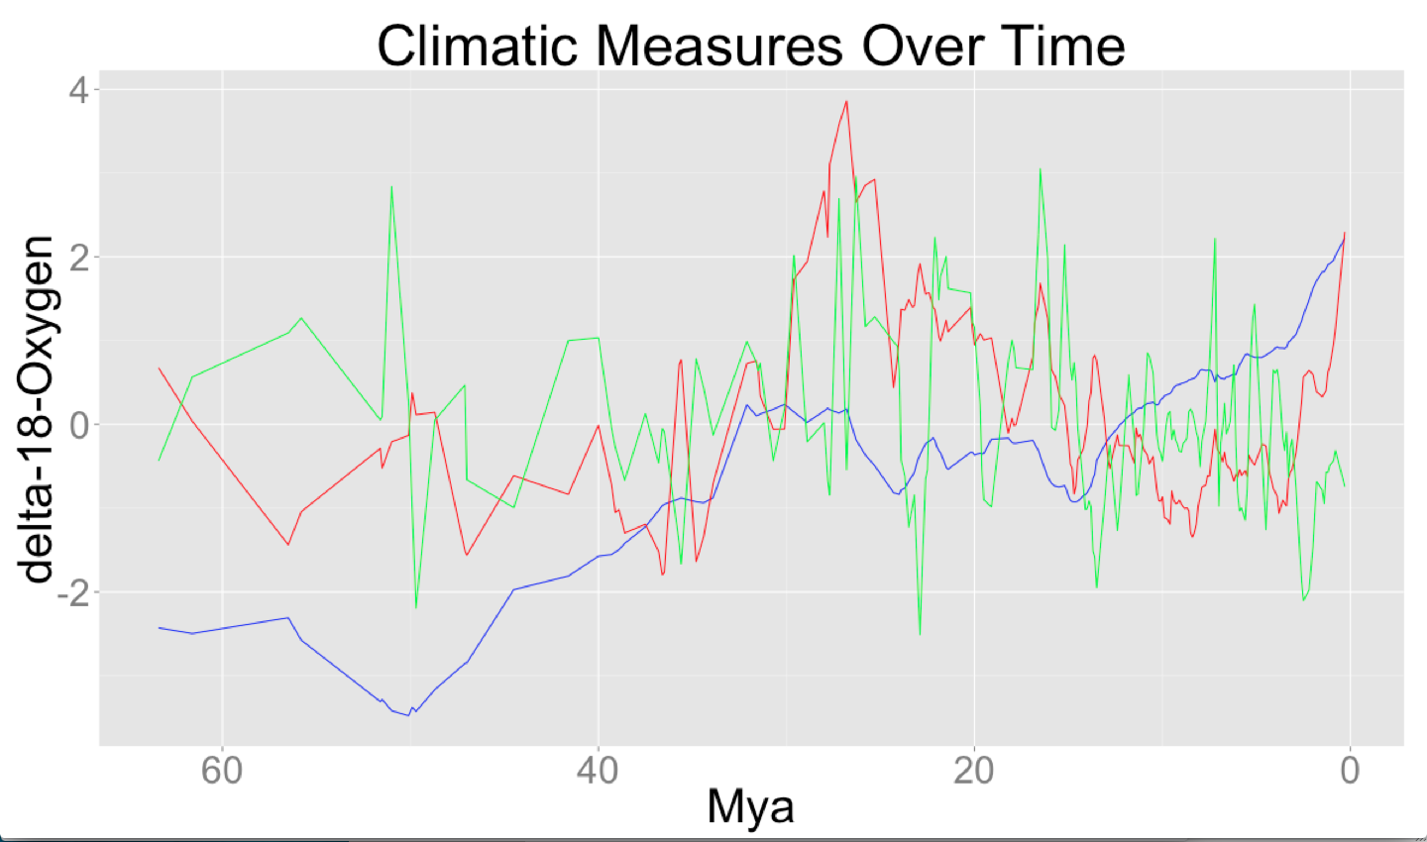
Figure X. Climatic measures of the oxygen isotope record over the last 65 My. Blue line=mean, red line=sd, green line=slope.
**Will improve this figure is we decide to keep it.

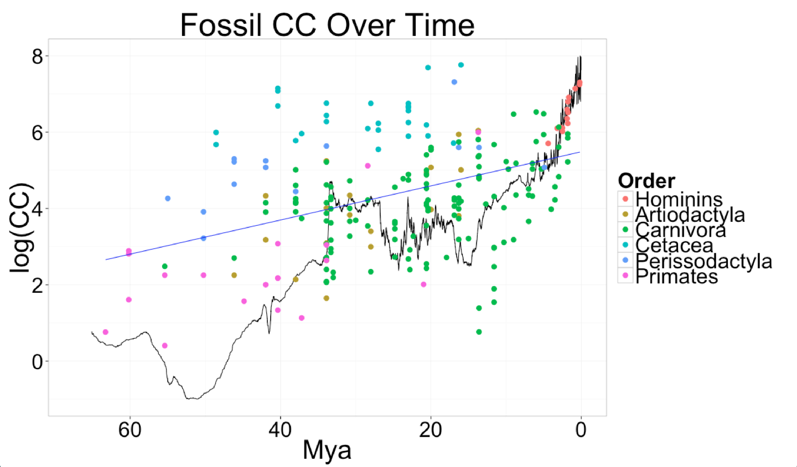
Figure X. Fossils CC over the last 65 Mya.
** Add label for O18 line. Move ylab over.

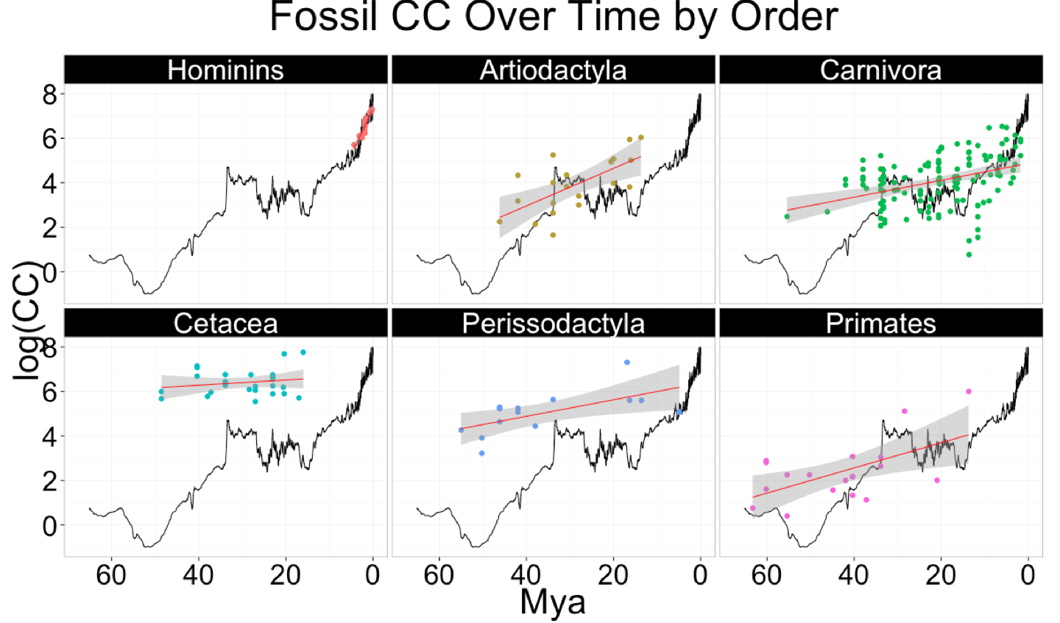
Figure X. Alternative way of showing fossil CC over time; split into respective taxonomic orders.
**Adjust axis labels and title.

Table X. Results of linear regressions in which fossil CC was the response variable and time (Mya) was the predictor variable. Negative estimate values mean that CC grew larger as we come closer to the present (Increase), positive estimate values mean CC grew smaller as we approach the present, and no significant means that there was no significant trend of CC in either direction (Stable).

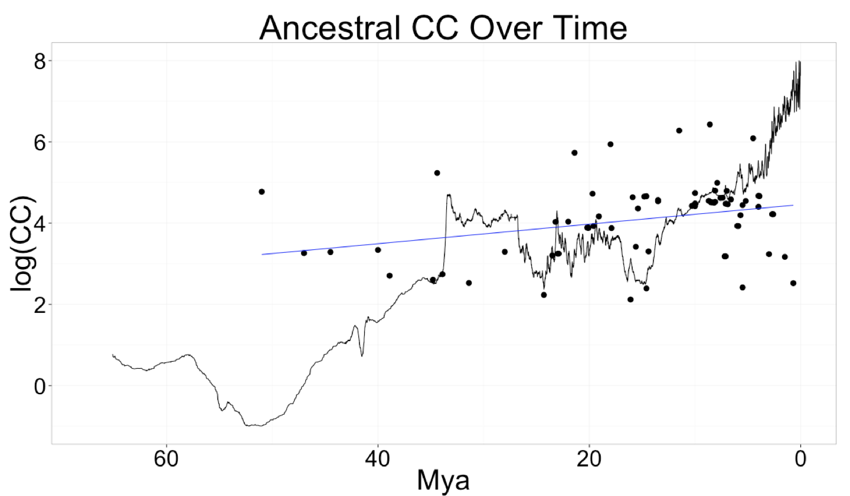
Figure X. Ancestral reconstructed CC over the last 65 Mya. OLS regression line in blue, O18 line in black.
** Label lines.

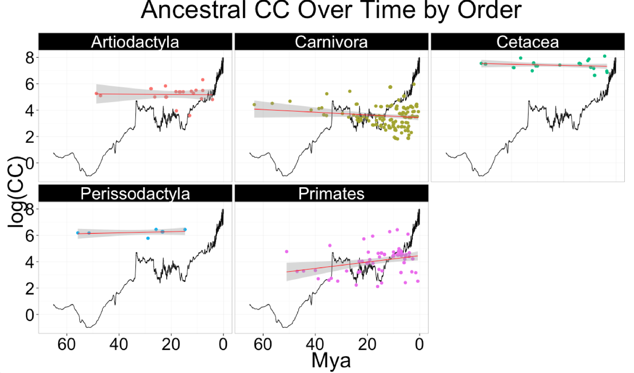
Figure X. Ancestral reconstructed CC over the last 65 Mya, split into their respective taxonomic orders.
** Adjust axis labels. Add x-axis to third column.

Will redo with table to include R2 values.
Table X. Results of linear regressions in which ancestral reconstructed CC was the response variable and time (Mya) was the predictor variable. Negative estimate values mean that CC grew larger as we come closer to the present (Increase), positive estimate values mean CC grew smaller as we approach the present, and no significant means that there was no significant trend of CC in either direction (Stable).

SUPPLEMENTARY MATERIALS

Table X. Results of multiple regression analyses in which ancestral CC was the response
variable and climatic measures (mean, SD, and slope of the oxygen isotope curve) were
the predictor variables. Analyses were first conducted with all orders grouped together,
and then divided into respective orders. Highlighted p values are significant at <0.05.

Table X. Fossil CC vs. Climate detrended.

Table X. Results of multiple regression analyses in which ancestral CC was the response variable and climatic measures (mean, SD, and slope of the oxygen isotope curve) were the predictor variables. Analyses were first conducted with all orders grouped together, and then divided into respective orders. Highlighted p values are significant at <0.05.

Table X. Ancestral CC vs. Climate detrended.

Table X. Summary of the CC vs. climate results using either the fossil or ancestral CC data sets. Values of 1, 2 or 3 were assigned to each cell depending on how many of the tested time intervals (1My, 400Ky, and 200Ky) were significant predictors of CC for a given taxonomic group.

